1. **What is the difference between error and exception?**

|  |  |
| --- | --- |
| **Error** | **Exception** |
| Error is classified as an unchecked type | Exceptions are classified as two types  1.unchecked type  2.Checked type |
| Error can not be handled through the program | Exceptions can be handled through the programs by using exception handlres  1.Try catch  2.try catch finally  3.Try finally  4.Try with resources |
| The package in error is java.lang.error | The package in exception is java.lang.Exception |
| Error is irrecoverable | Exceptions are recoverable |
| **EX:-**OutOfMemoryError ,IOError | **EX:-**NullPointerException , SqlException |

**2.How can we handle exceptions in java?**

Exceptions can be handled in two ways:

1. If you know if the exception is not critical if you want to proceed further then you can use try catch
2. Throw a specific exception if it is critical

**3.What is Throw and Throws?**

**Throw:-**  Throw keyword is used throw an exception explicitly in the code, inside the function or the block of code

**Throws:-** Throws keyword is used in the method signature to declare an exception which might be thrown by the function while the execution of the **code.**

**4.Why do we need exception handling?**

 The exceptions should be handled to prevent any abnormal termination of a program. The program should keep running even if it gets interrupted in between.

5. **what is exception hierarchy?**

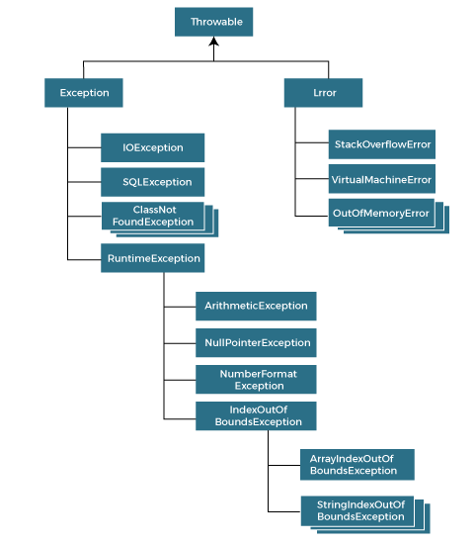

**6. how can we create user-defined runtime and compile time exception?**

To create a checked custom exception, it must extend Exception or its child classes.

We can create the custom unchecked exception by extending the RuntimeException in Java. Unchecked exceptions inherit from the Error class or the RuntimeException class

**7.What is try with resources?**

The try-with-resources statement is a try statement that declares one or more resources. The resource is as an object that must be closed after finishing the program. The try-with-resources statement ensures that each resource is closed at the end of the statement execution.

You can pass any object that implements java.lang.AutoCloseable, which includes all objects which implement java.io.Closeable.

**8.Can we have try, try and finally without catch block.**

we can have try without catch block by using finally block.

You can use try with finally. As you know finally block always executes even if you have exception or return statement in try block except in case of System.exit().

The finally block always executes when the try block exits. So we can use finally without catch but we must use try. The finally block always executes when the try block exits. So we can use finally without catch

**9.Explain the chart and explain the throwable error exception relation.**

The Throwable class is the superclass of all errors and exceptions in the Java language.

Only objects that are instances of this class or one of its subclasses are thrown by the Java Virtual Machine or can be thrown by the Java throw statement.

**10. what is getmessage and printstacktrace?**

The getMessage() method returns a description of the error or behaviour that caused the exception to be thrown.

The getMessage() method of Throwable class is used to return a detailed message of the Throwable object which can also be null. One can use this method to get the detail message of exception as a string value.

The printStackTrace() method in Java is a tool used to handle exceptions and errors. It is a method of Java's throwable class which prints the throwable along with other details like the line number and class name where the exception occurred

**11. How to write proper exception handling in java?**

1. All exceptions must be a child of Throwable.
2. If you want to write a checked exception that is automatically enforced by the Handle or Declare Rule, you need to extend the Exception class.
3. If you want to write a runtime exception, you need to extend the RuntimeException class.

.